Level 1 DFD

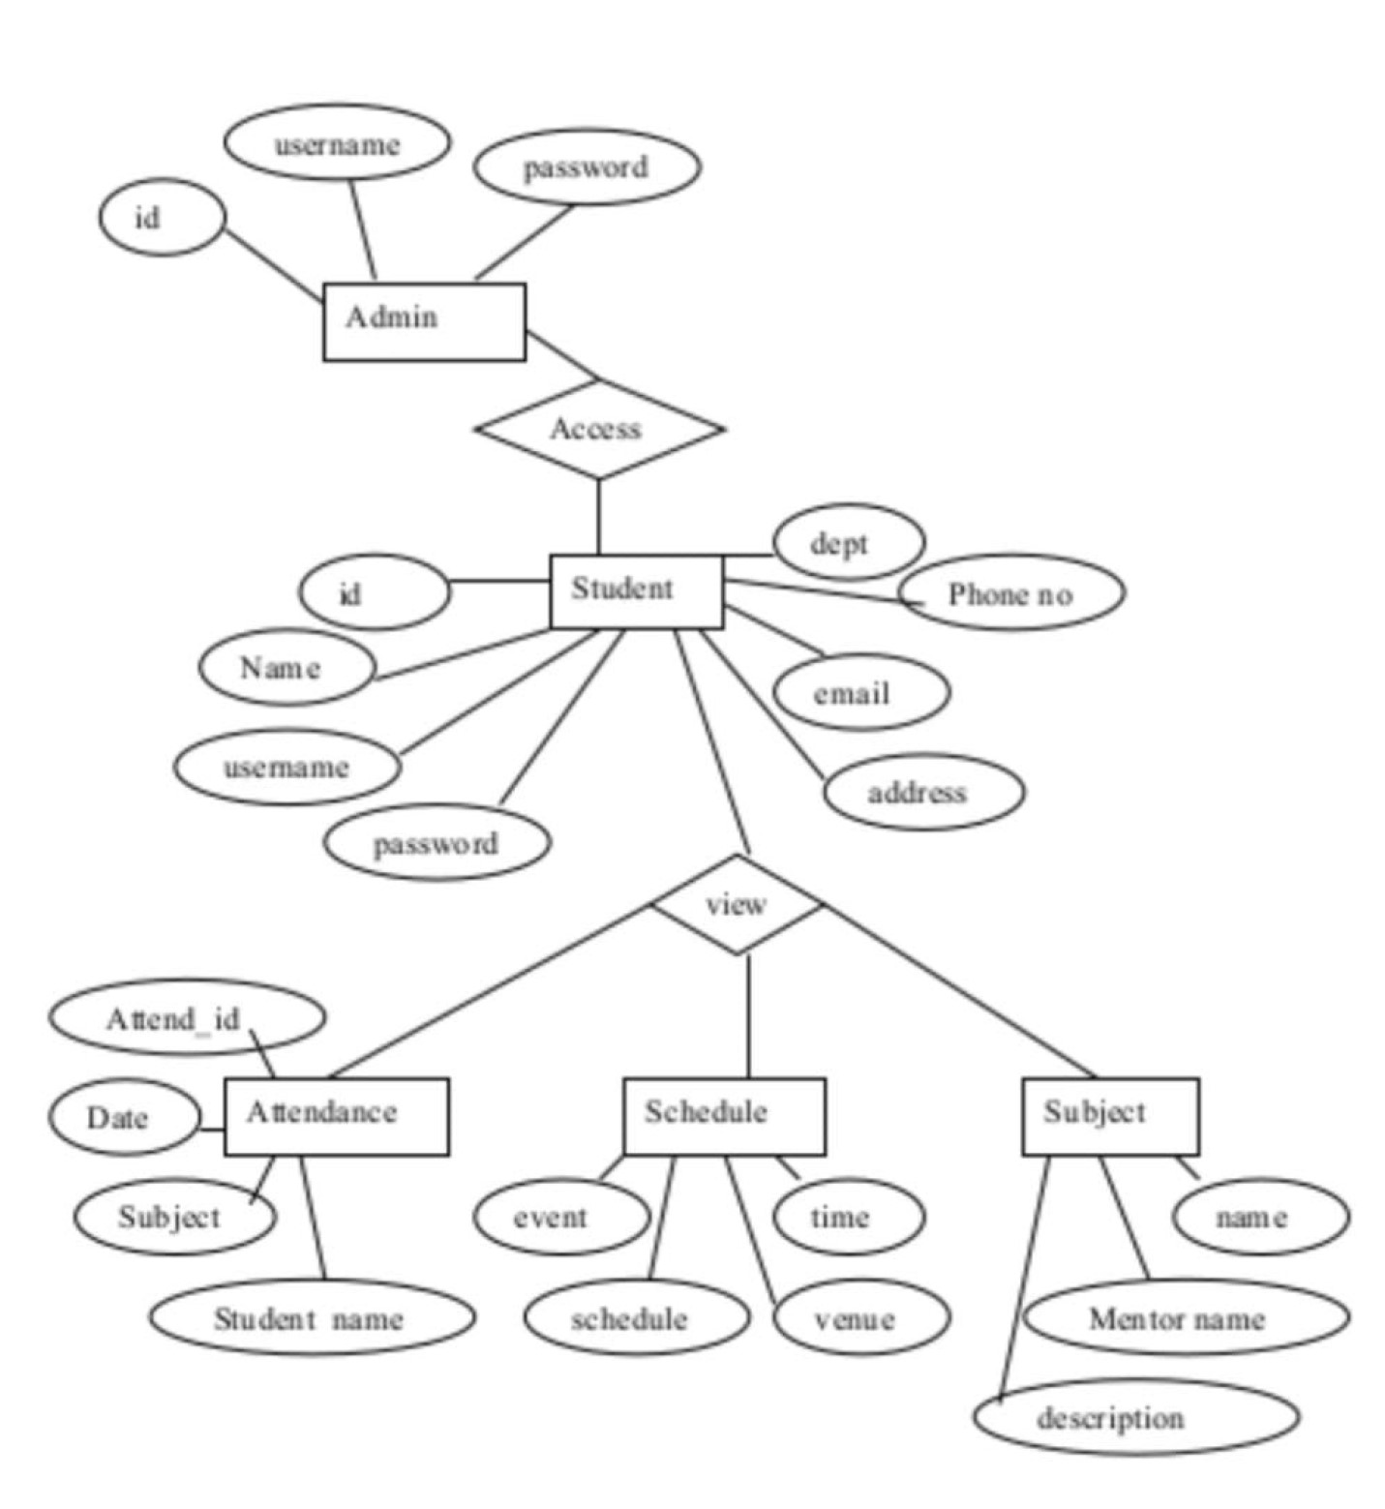

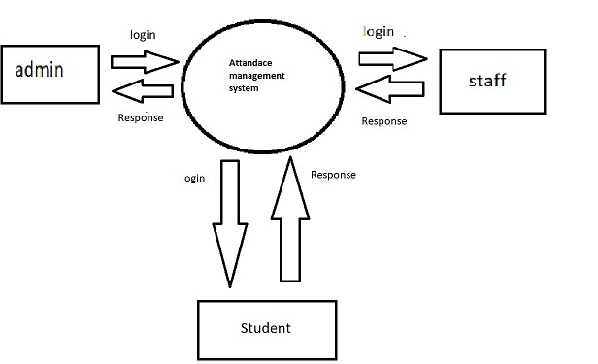Level 0 dfd(context diagram) – Attendance Management System